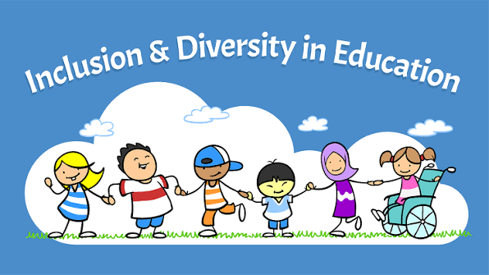

Jessica Burnett
The University of Arizona Global Campus
ECE 405: Children and Families in Diverse Society
Silvia Graham
June/15/2026

The purpose of this handbook in promoting inclusivity, and social justice in diverse educational settings is to promote inclusivity, equality, and social justice in early childhood settings. It to creates a safe space for children to feel safe and value while learning. The primary purpose is to dismantle early biases, foster empathy, and ensure all children regardless of background, race, or ability. It is to educate young children on development and educational opportunities.

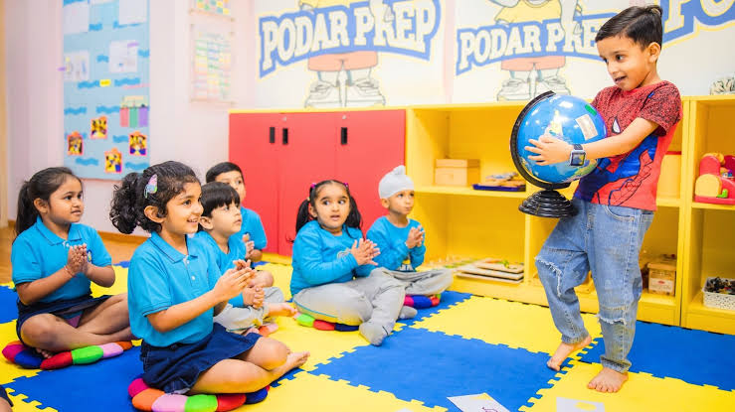
Earlychildhoodof DIVERSITY
Gilbert Arizona | 916.555.0123 | jessicajou268@gmail.com |

CLASSROOM culture
I will create a classroom that builds RESPECT-AND build on all what CHILDREN brings  I will create an ENVIRONMENT that respect values and INCLUDE each child and family |  |  |  | Classroom  Culture means understanding and respecting diversity  Classroom management expectations  Broad and visual  Incorporate cultural context, culturally responsive  Teaching, Inclusive language, Open discussion
June 2026  July 1026 |  |  |  | Traditional, inclusion, conflict resolution, engagement, collaboration, and assumption

Positive Partnerships
-I will welcome families to my ECE cultural and explain the impact of diversity of children, learning and development and socio- emotional wellbeing. Welcome to the families to this fun year of being your child preschool teacher. we will celebrate diversity as an honor as a learning community. It is to build a foundation where children thrive, empathy depends, and children feel a strong, secure sense of self.

-strategies I will use to create inclusive and fair learning, environments for children and families. I will adapt my diversity curriculum and physical classroom. as early childhood teacher, I will blend developmental milestones with fair inclusive practices through several strategies. I will support my students by developing cognitive and language skills. I will bring all families culture aspects and beliefs into my classroom.

-I will use culturally responsive practices to support the learning and development of all student students. I will recognize, confirm, and incorporate student's diverse backgrounds into daily lessons. when my students learn in my classroom, they will feel secure, respected value, happy, and interested to learn.

I will consider my preschool basis to promote a respectful, early childhood environment by engaging in my student's reflection understand, understanding, and attitude.
Culturally Responsive practices
Family night
Whole group activity

Storytelling & Rhythm Circle
An interactive session where families/ diverse families and children get together with their own family to a shared story and explore music together to other families and children.
Steps to Complete:
- Arrange the Circle: Invite all families and children to sit together in a large circle on a big rug inside, outside, or grassy area.
- Introduce Rhythm: Start an easy group rhythm (e.g., patting knees twice, clapping hands twice).
- Start the Story: Begin an interactive, collaborative story/ Have a great introduction introducing the story. (e.g., "Once upon a time, there was a purple dragon who...") and have fun of yarn to pass around the circle.
- Pass and Build: The person holding the yarn shares the next sentence of the story, keeps hold of a string, and gently tosses the ball to another family.
- Visual Conclusion: Once everyone has contributed, the resulting yarn "spiderweb" physically illustrates how the entire group is connected.

Centers- 3 center-based activity incorporating cultural responsiveness

My Center-based Family Night activities will be hands-ons for children of all age and families. It will include highly visual, low pressure, art, creativity, and movement. It will be safe culturally responsive centers—like multi-language storytelling, global music and movement, and family art projects—It encourages parents to share their heritage while helping children develop empathy and inclusion.

Closing Reflective Activity
Summary connection (The tail of the day)

How the Activity Works
I will hold a ball of clay then I will pass it around to a parent or child. The person would share their insight or favorite moment of the event it will continue until every family member and child hold a piece of clay making their own small ball. It will create each family unique small ball at the end to get toss for ending the closure of Tail of The Day
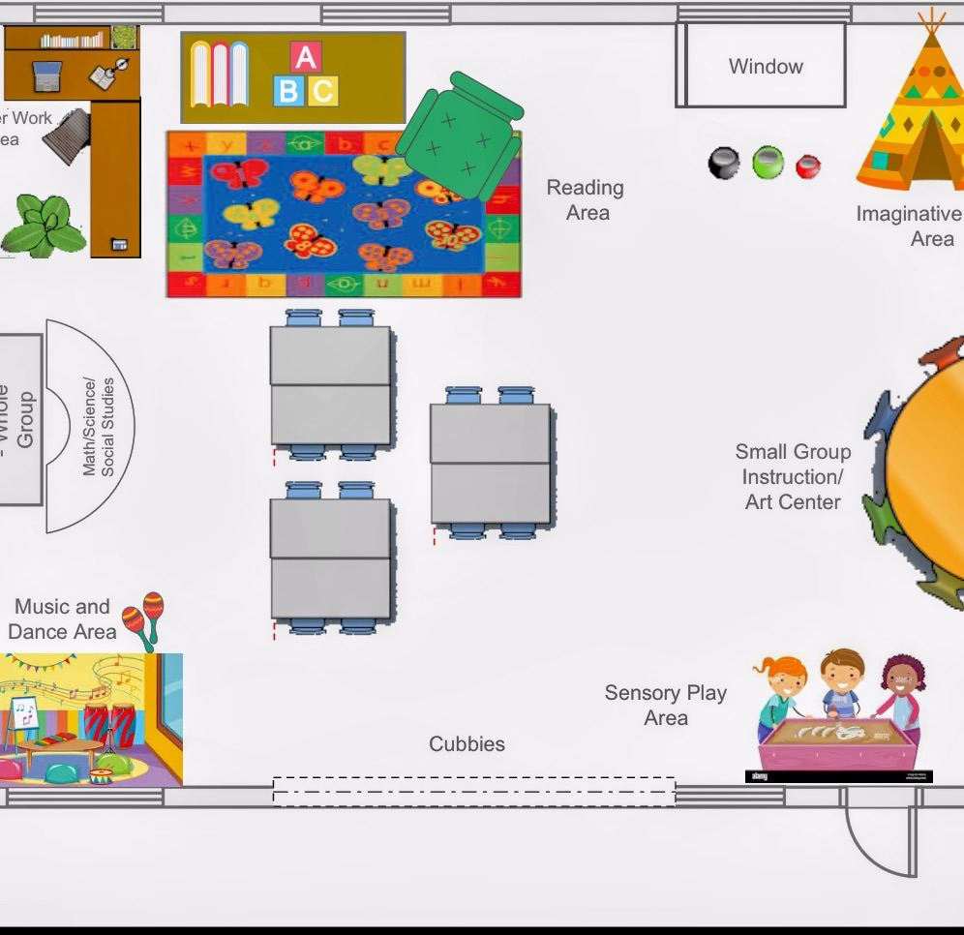
Mrs Burnett ECE classroom layout

Five key areas where welcoming spaces created build classroom communities
1.Reading area -understanding words and understanding the story
2. Imaginative area-children will create a sense of imagination (play pretend house)
3.Small group instruction art center- children of a small group does painting and art
4. Music and dance area-celebrates diverse cultures and traditions
5.Sensory Play Area-encourages hands on activities
Titles and brief summaries of five age-appropriate children’s books I could use in the library area to support respectful ECE environments.
6-12 month- Animals by Darling Kindersing ( Baby’s touch and feel the animals in the book)
1 to 3 yrs-Books by the Bushel: this selection of books includes board books, bath books, paperback, touch and feel, and lift a flap books. It focuses on rhythm, repetition, sensory engagement, and foundation of concepts like coloring animals.
4-6 yrs- The very hungry caterpillar by Eric Carle: the lifecycle of an insect it explores things of transformation, healthy choices in growth while teaching core concepts like counting the days of the week.
7 to 9 yrs- Brave little Ruby by Shannon Yauger: when Ruby Bridges attends a new school in the 1960s, she is excited but confused. Why does she need an escort by US marshals? Why is she the only one in her classroom? How could her skin color makes such an enormous difference in the way others treat her? Ruby learns to be “Brave Little Ruby,” a trailblazer who helped change hearts and our nation history.
10 to 12 yrs-All I can be by Mercer Mayer: It’s an inspirational children's books that combines two classic stories, “when I get Bigger” and “when I grow up” into one volume, encouraging kids to dream big about their future.
Fostering Professional Growth
My vision for continue growth as a professional
My learning in this course, help me grow as a reflective, responsive educator by wanting me be more mindful in supportive and respectful of educating young children on diversity.ECE 405 gave me a better insight on wanting to help and advance children of all cultures. It’s very professional to enhance child education to have high quality of education.
I will commit to expand knowledge of belief and values, communication, and behaviors across cultural groups to continue to inform my experiences in school and in larger social context. I will post posters on the wall of my student's cultural values, and beliefs. I will also discuss their beliefs and cultural aspects.
I will continue to find, learn, and use new skills that offer a culturally responsive approach to educate in students and communicating with families across cultures. I will do reflective practices and skill audits.
Five virtual resources
Coursella— to build my résumé in complete modules at my own pace
Google Scholar-to have direct access to research papers abstract in court options
Project Gutenberg-I will use this online library to read class literature and historical text
Khan Academy- I will use this nonprofit for brushing up on math science and economics
YouTube-i’ll use this for visual and auditory learning
I will recognize the value of diversity in early childhood education settings, including diverse cultures, language, ability, and family structure by building trust with my students/ families and adapting to each one culturally diverse background.

References
- Diversity Toolkit: Cultural Competence For Educators.
- Teaching for Social Justice in Early Childhood Classrooms: Developing Humanizing and Critical Spaces for Young Children.
- Culturally Responsive Toolkit exemplar.

U. S Department of Education (.gov)
https://www.ed.gov
Early childhood education/U. S
Department of Education

https://www.google.com/url?q=https://www.ed.gov/birth-to-grade-12-education/early-childhood-education&sa=U&sqi=2&ved=2ahUKEwjRoaHRzI6VAxWnHUQIHVkvLK4QFnoECB4QAQ&usg=AOvVaw1IFrsoruTWRyJCPEnQCMBp

Arizona Department of Education | (. gov)
https://www.azed.gov

